**1. Business analyses tasks – Dimensions**

Task 01. Create Packages for Reload Dimension from SA_*

User DW_CL was granted with necessary privileges which were added in attached file init_users.sql.

Tables on DW Layer were created by running scripts from directory \dw\tables\.

Necessary sequences were created on DW_CL Layer by running scripts from directory \dw_cl\sequences\.

Package pkg_etl_dim_programs_dw was created to reload data about programs and theirs managers (in different tables at DW Layer) from source table Programs. Package pkg_etl_dim_programs_dw (presented in directory \dw_cl\packages\) consists of the next procedures:

1**. Load_managers**- to load data about managers using Execute Immediate with Bind Parameters in table dw.t_managers. Result of procedure execution is presented below.

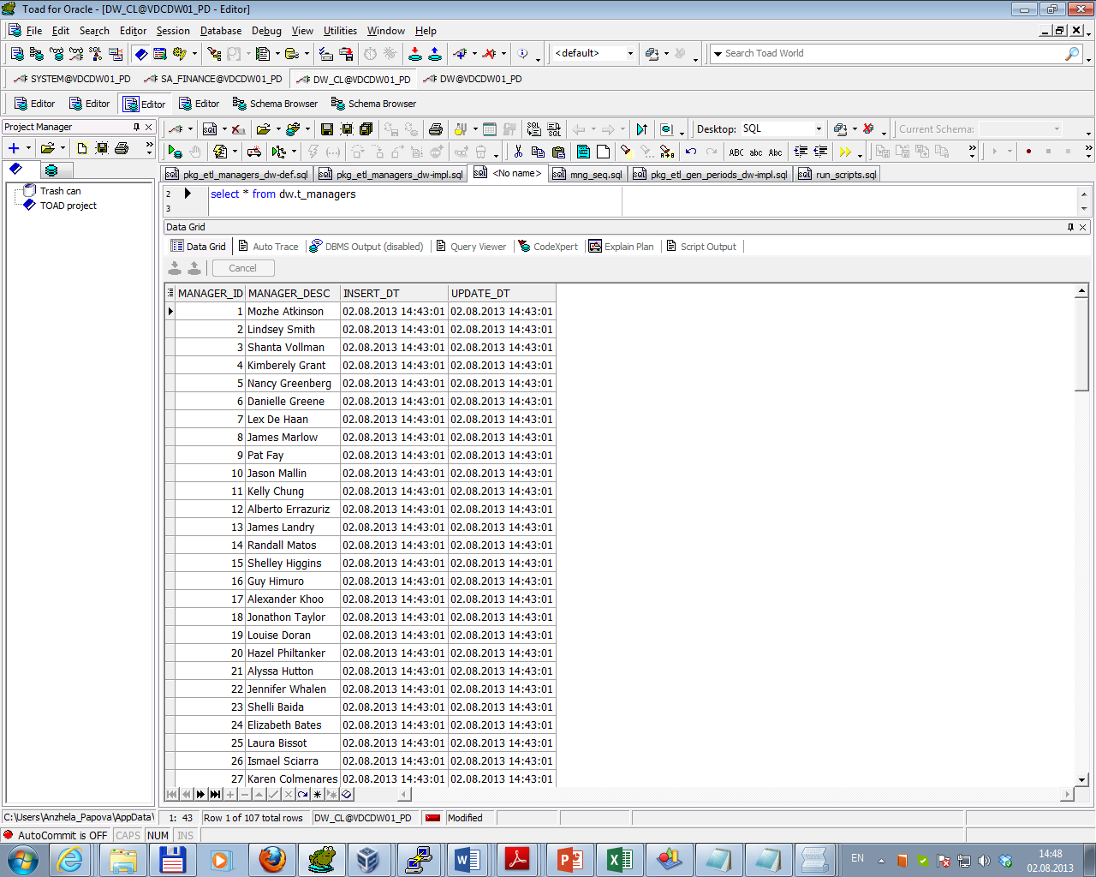

After multi execution result is the same.

To test data for consistency was used result of expression (direct and inverse) as select from procedure execution minus select data from source table. Test results are presented below.

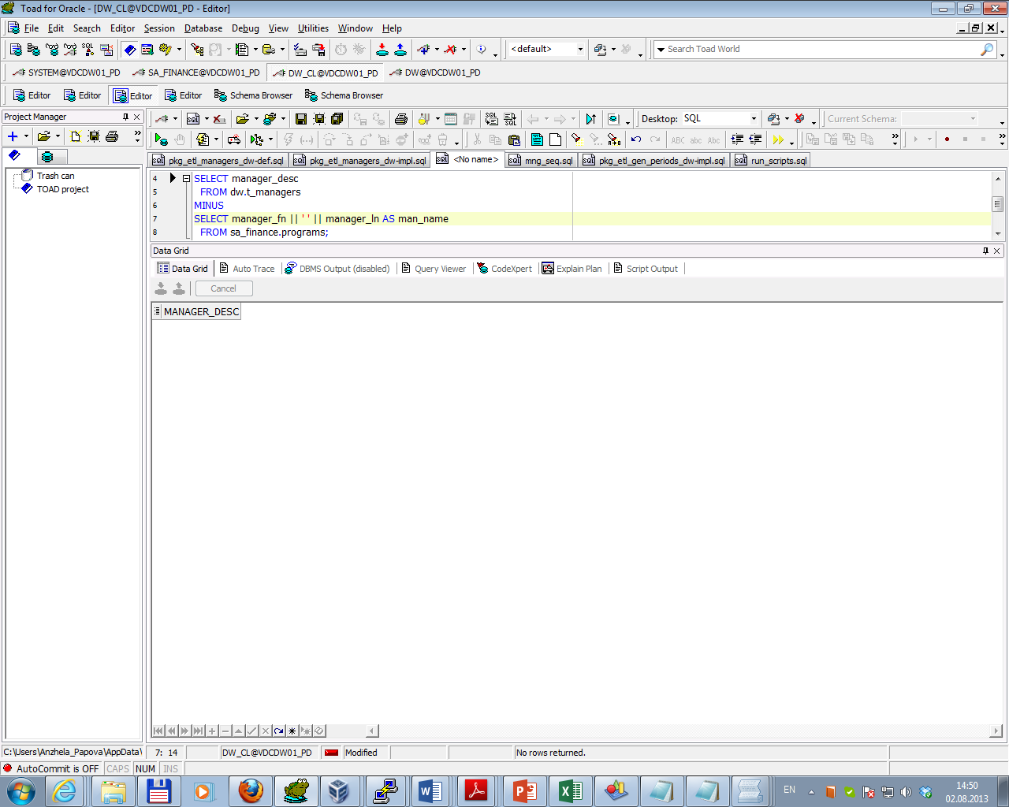

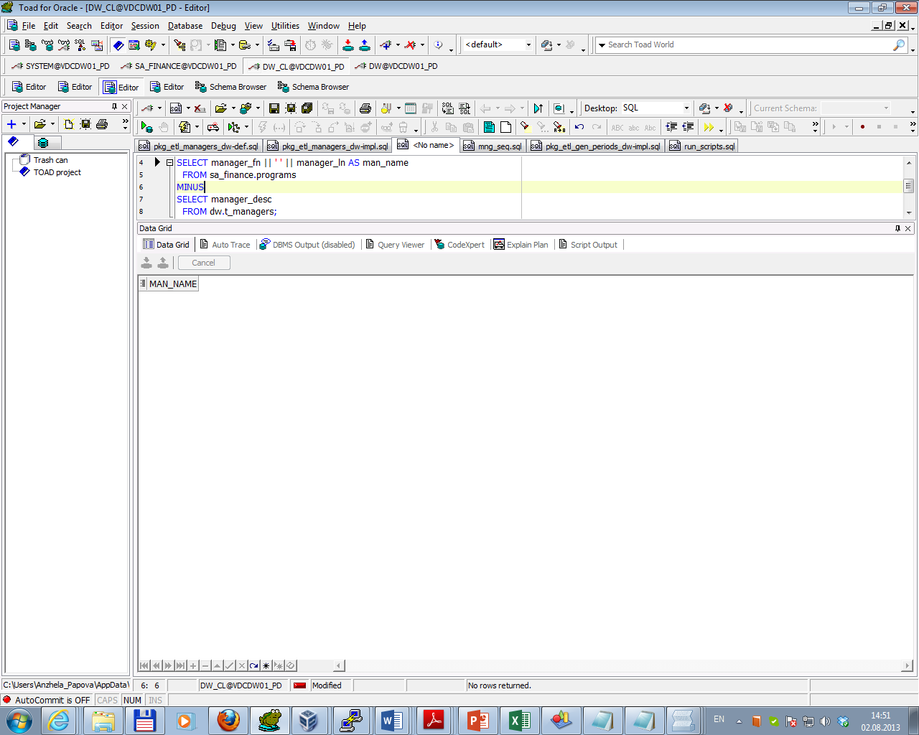

2**. Load_programs** - to load data about programs using DBMS_SQL.TO_REFCURSOR Function in table dw.t_programs. Result of procedure execution is presented below.

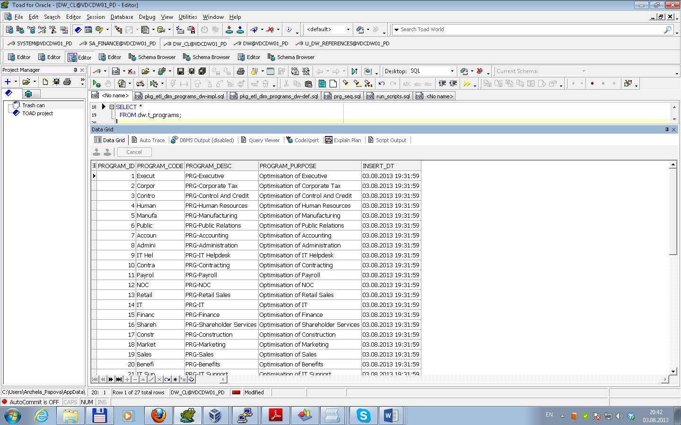

After multi execution result is the same.

To test data for consistency was used result of expression (direct and inverse) as select from procedure execution minus select data from source table. Test results are presented below.

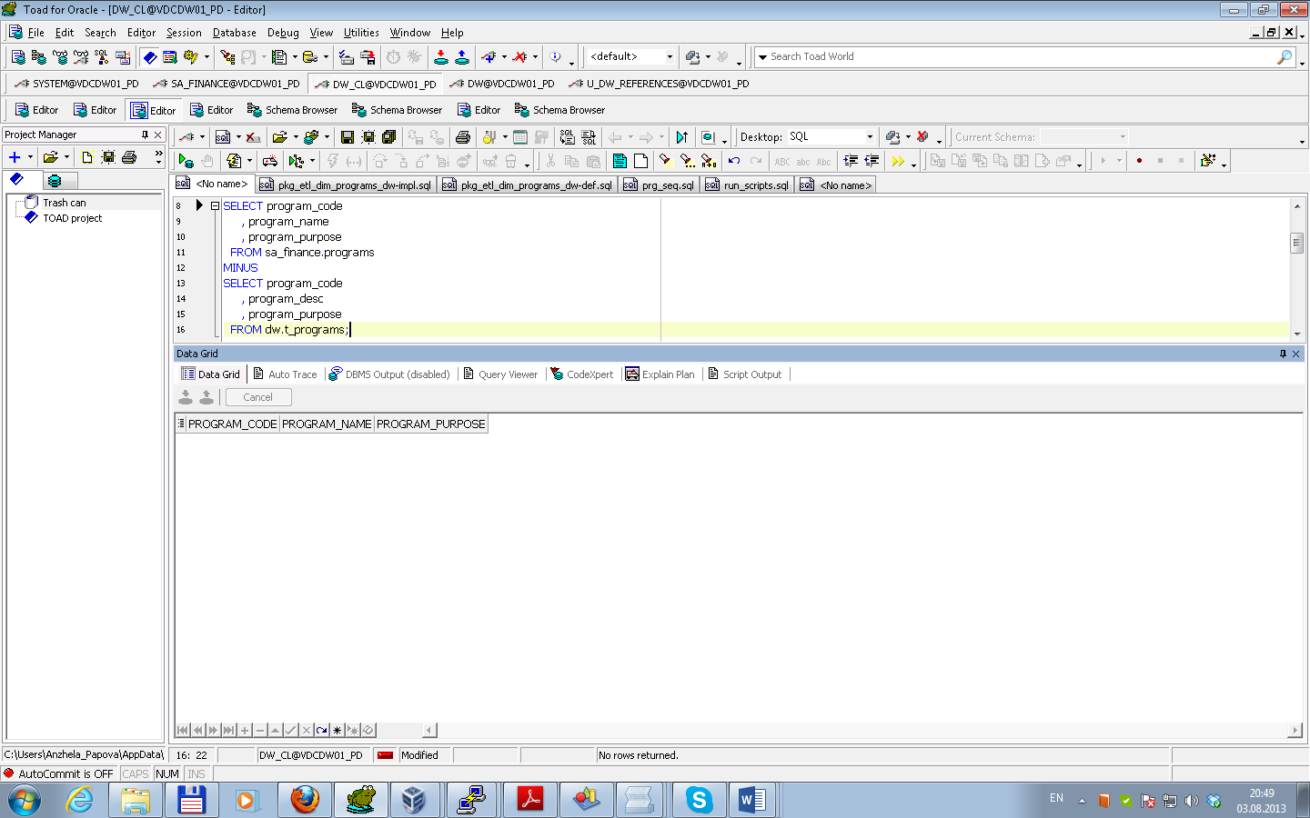

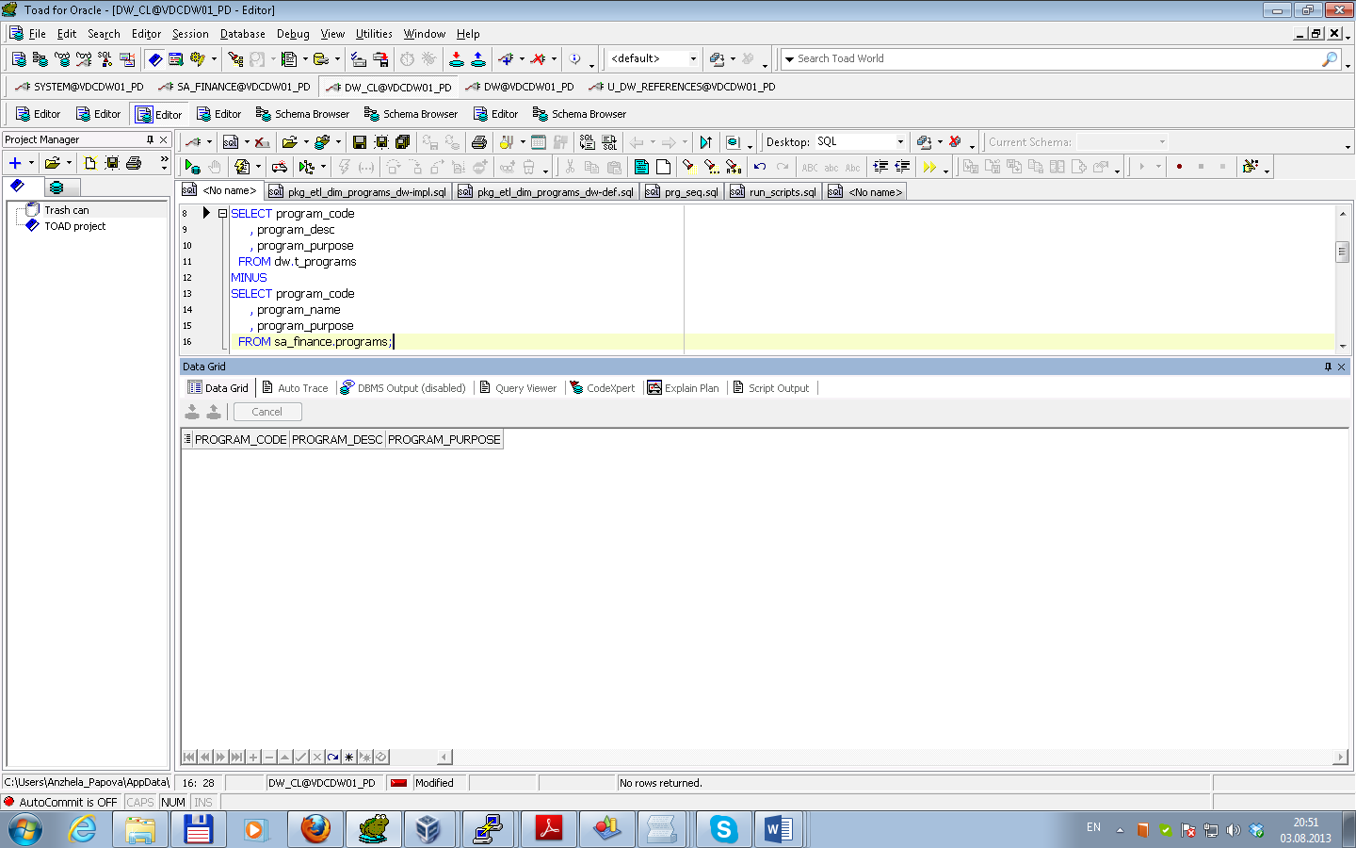

3**. Load program_manager** - to load data about programs’ managers using DBMS_SQL.TO_CURSOR_NUMBER Function in table dw.t_program_manager. Result of procedure execution is presented below.

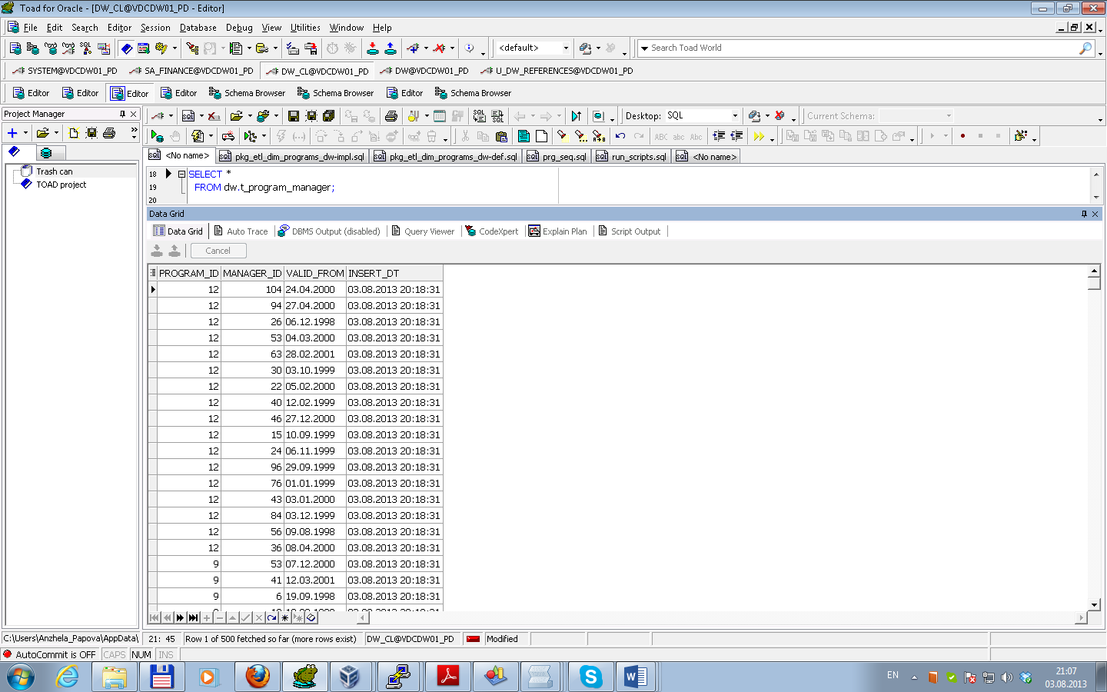

After multi execution result is the same.

To test data for consistency was used result of expression (direct and inverse) as select from procedure execution minus select data from source table. Test results are presented below.

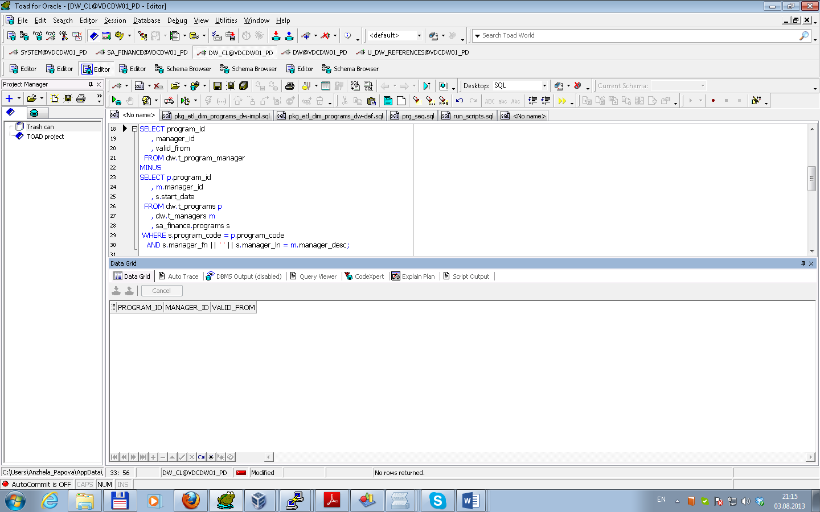

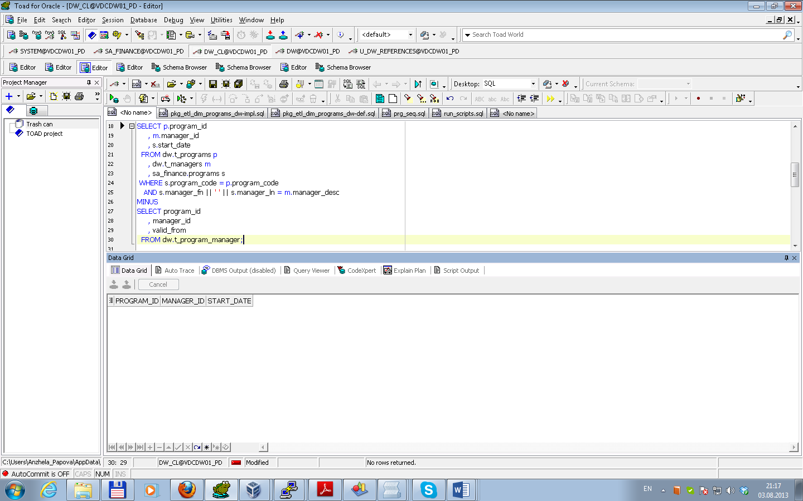

**2. Business analyses tasks – Reports**

Task 02. CREATE Monthly Reports Layouts

Report layout Quarterly analysis of the World Bank funding was created according Business Solution Proposal (presented in attached file WB_funding_quarterly(model).xlsx).

To use Model Clause fact table fct_finance was created (script is in attached file fct_finance.sql). Result of script running is presented below.

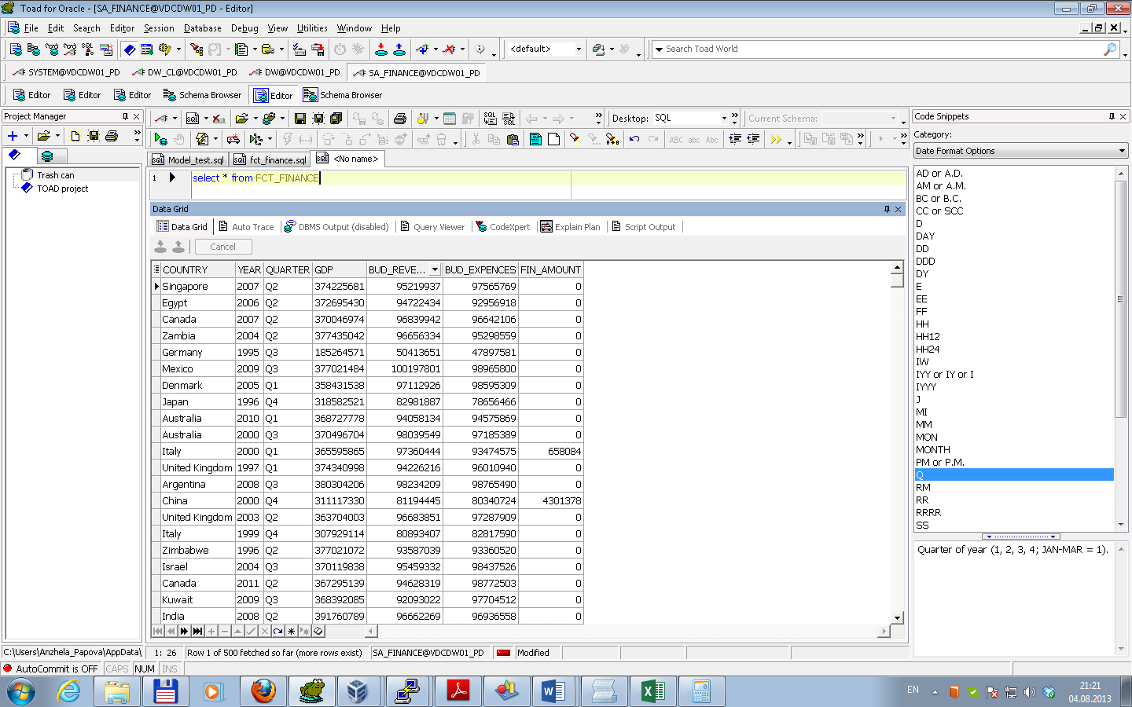

Model Clause was used to create report according the layout (script is in attached file Model_test.sql). Result of script running is presented below.

